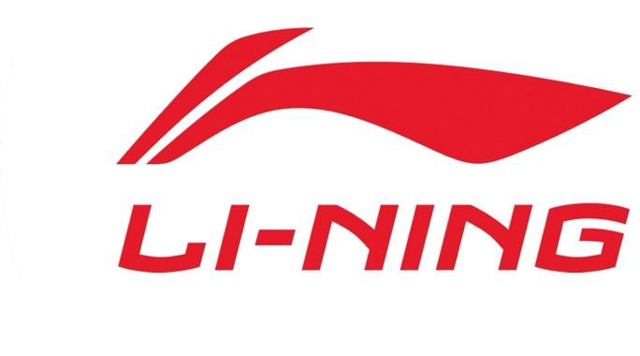
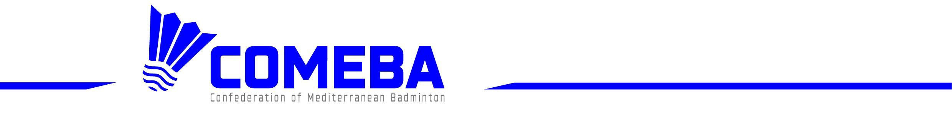

I FEEL SLOVENIA LI-NING COMEBA SERIES 2025

Sport hall Tri Lilije Pozenelova ulica 22, 3270 Lasko

5nd-7th SEPTEMBER 2025

FIRST COMEBA TOURNAMENT
(Sanctioned by the Badminton Europe Confederation)

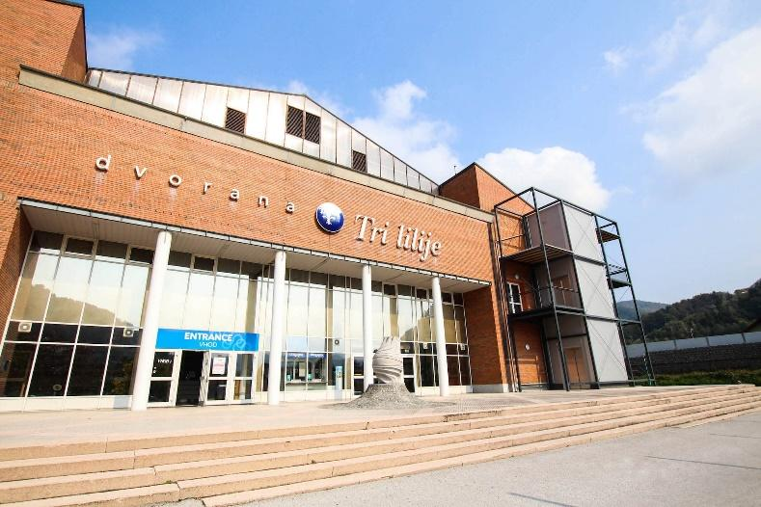
* * * Tournament Director
Gasper Krivec
All communications to:
Badminton Association of Slovenia, Ostrovrharjeva 4, 1215 Medvode Mob : + 386 41 942 988
E-mail: gasper.krivec@outlook.com
Website: https://slovenia-open.badminton-zveza.si
Entries Close: Tuesday September 2nd 2025

Organizer

Venue Referee

Schedule
Badminton Association of Slovenia, Ostrovrharjeva 4, 1215 Medvode
Sport hall Tri Lilije, Pozenelova 22, 3270 Lasko

Patrik Riboli (SLO), patrik.riboli@hotmail.com

All competitors must be prepared to play at the times determined for the events for which they have entered. The Order of Play is:

Friday 5nd of September 2025
17.00 | First Rounds
Saturday 6rd of September 2025
9.30 to 19.00 | Men’s & Women’s Singles
 | Men’s & Women’s Singles
Men’s & Women’s Doubles
Mixed Doubles
Sunday 7th of September 2025
9.30 | Finals all disciplines

Entry fees One discipline 40 EUR
Two disciplines 60 EUR
Three disciplines 80 EUR
The Member that enters a player into a COMEBA tournament is responsible for paying the entry fees for that player. The entry fees become due if a player is entered and has not been withdrawn when the entry deadline passes.
The entry fees will not be refunded in the event of a withdrawal. For all the withdrawn players the Organizers can invoice the entry fee to the relevant Member.
PAYMENTS: Badminton Association of Slovenia will issue an invoice and send it to the player's federation.

The bank transfer information: BADMINTONSKA ZVEZA SLOVENIJE
Ostrovrharjeva 4, 1215 Medvode, Slovenija

Bank: Delavska hranilnica d.d., Miklošičeva 5, 1000 Ljubljana, Slovenia

S.W.I.F.T. Code: HDELSI22,
IBAN Code: SI56 6100 0000 1884 378
Entries All entries must be sent via email to this address:
info@badminton-zveza.si
Entries must be submitted not later than:
- Tournament organizers will also try to seek maximum acceptance list, so arrangements due to late entry submission could be made. Last entry date for players is 02.09.2025 15.00 (Slovenian local time).
- Each country participating in the event is allowed to apply 2 player or pairs per event. Host nation is allowed to have max 4 participants or pairs per event as long as the draw doesn’t exceed max 16 entries per discipline.
Only player outside BWF TOP 200 in singles and outside BWF TOP 170 in doubles discipline can enter I FEEL SLOVENIA LI-NING COMEBA 2025. This rule was approved by the Board of COMEBA and ensures that COMEBA events
remain true to their developmental purpose. We kindly ask you to include this information in the invitation.
In accordance with regulation § 9.2 and § 9.3 in BWF Statutes, Section 5.3.3.1: World Ranking System, an event must contain at least 8 (eight) competitors in the first published version of the main draw. If the required number of competitors is not met in the first published version of the main draw, this particular event shall not count towards any ranking, i.e. BEC Elite Circuit Ranking and BWF World Ranking.
In accordance with regulation § 9.4 in BWF Statutes, Section 5.3.3.1: World Ranking System, the first published version of the main draw of an event must contain at least 1 (one) entry from a Member other than the hosting Member. If an event does not contain at least 1 (one) entry from a Member other than the hosting Member, this particular event shall not count towards any ranking.
Slovenia Badminton federation is not liable for any costs incurred by third persons (players, coaches, umpires, team managers etc.) because of an event not having enough competitors to count for the rankings.
Players cannot be entered unless they already have a BWF ID- number. In case you wish to enter players, who do not have a BWF ID-number, please contact the BWF office well in advance of the tournament, so that the players concerned can get a BWF ID-number before the closing date of the tournament.
Late entries will be considered in accordance with
COMEBA regulations.
Organizers are allowed to refuse entries if players have outstanding fees from a previous year.
Compliance with BWF GCR 7.9: “In making or authorising entries, the Member concerned is reconfirming its acceptance, and acceptance by the Players being entered, of the BWF’s regulations and Disciplinary processes.”

Events Men’s Singles, Women's Singles, Men’s Doubles, Women's Doubles, Mixed Doubles. The number of players/pairs to be accepted for the main events in Singles 32, in Men’s, Women’s Doubles 24 and in Mixed Doubles 32.

System of the
Competition K.O. system according to the Laws of Badminton and General Competition Regulations of the BWF.

Eligibility Participation is open to players of any National Association recognized by the BWF.
Shuttles LI-NING G800
Courts 5 YONEX COURTS

Closing date September 2nd 2025

Withdrawals Please ensure that the organizer will be informed immediately when a player has to withdraw, preferably together with the reason for withdrawal. Any withdrawal after the Tuesday 02.09.2025 immediately preceding the draw, for any reason whatsoever,renders the Member concerned liable to an amount of USD 150,00 for the inconvenience caused by the withdrawal.

Any player not showing up at the tournament, without having been withdrawn in advance, renders the Member concerned liable to an additional amount of USD 500,00 for the inconvenience caused by the “no show” (as defined in BWF General Competition Regulations).

Visa If you need Visa for Slovenia, please ask the Slovenian Badminton Association (gasper.krivec@outlook.com) for the official Invitation letter. It is advised to arrange the VISA in time.
Draw Draw will be made by Official umpire.
World ranking date used for M&Q report – 5th August 2025
M&Q report release date – 8th August 2025 World ranking date used for seeding and draws – 5th August 2025
Withdrawal deadline – September 2nd
Draw date – 2nd September 2025
Date for the team managers meeting: Wednesday, 3rd of September 2025, 20.00 Sporthall sport hall Tri Lilije

Condition of
play The tournament will be played in full accordance with the Laws of Badminton and the General Competition Regulations adopted by the BWF as well as the BEC Elite Circuit Regulations.
Competitors must be prepared to play at the times determined for the events for which they have entered. Competitors will be scratched if not ready to play when called.

Local
transport Free transport will be provided from the airport (Ljubljana Joze Pucnik Airport), train stations (Ljubljana) to the venue/official hotels if accommodation has been booked in official provided hotels.

The transport should be booked through web page and app.
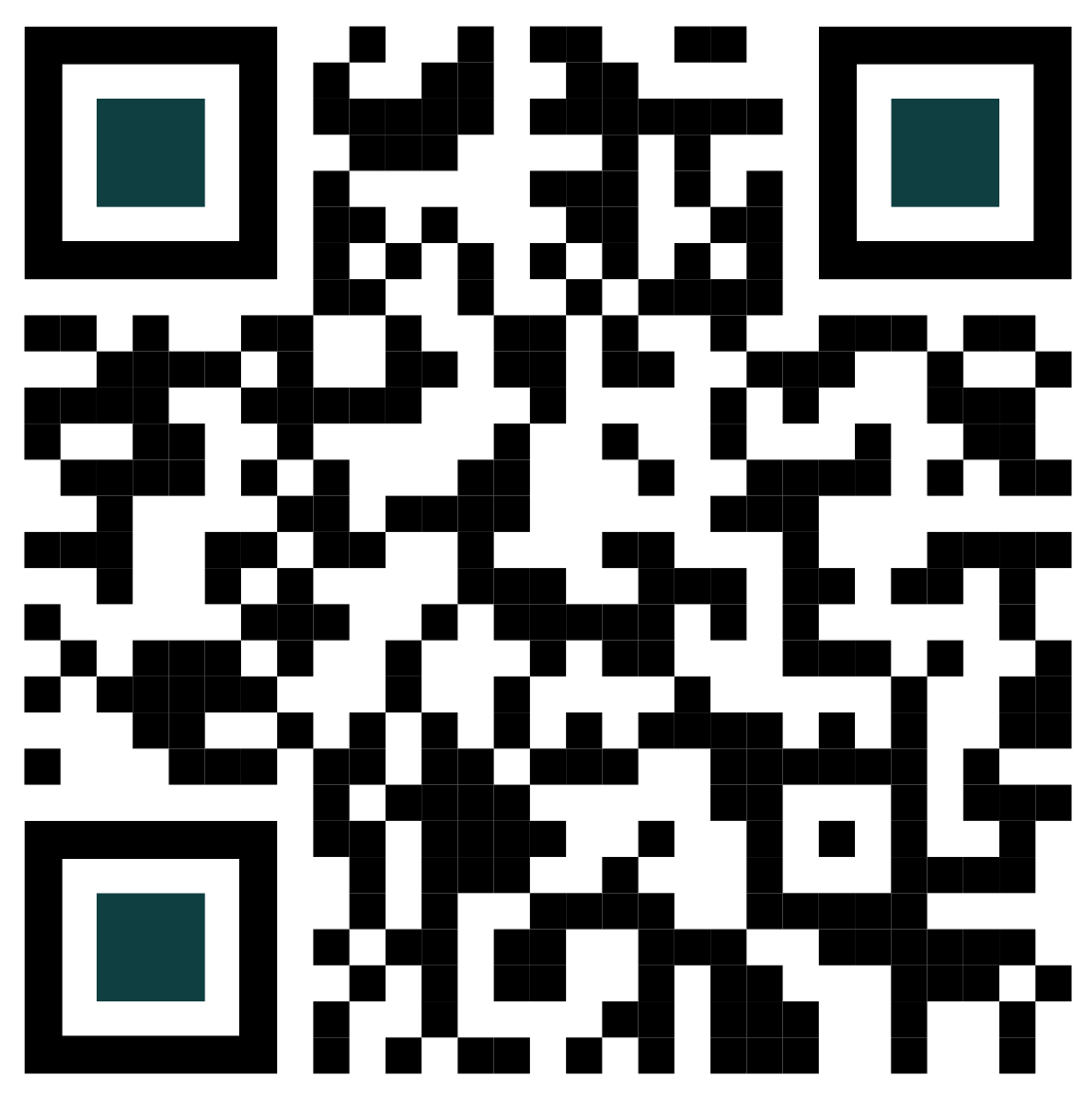

The deadline is 25. 8. 2025

Players shall not plan their departure less than 2 (two) hours after their last match is planned to conclude. If a player is unable to compete due to early departure, he/she shall be penalized by Forfeiture of rewards (removal of Elite Circuit ranking points and shall not be awarded prizes or prize money). Badminton Europe shall propose to BWF that the gained BWF ranking points are also removed. (Regulation 9.5 in Badminton Europe's Elite Circuit Regulations)

Accreditation Accreditations for participants need to be requested through our app:

Entry to sport hall without accreditation will not be possible.

Medical
service A physician will be present in the Sports hall during the tournament.

Insurance Member and/or Organizer may be liable for claims originating from the damages incurred by the participants and/or any other persons, arising from or in connection to the particular BEC Elite Circuit tournament, according to local Law. COMEBA is not liable for any such claims, actions, damages, costs or expenses of any nature whatsoever, including but not limited to injury or loss to person or property, arising out of or in any way related, directly or indirectly, to the particular BEC Elite Circuit tournament. It is recommended that Member and/or Organizers purchase a proper Insurance Policy that would cover their potential legal liability. (regulation 3.6 of BEC Elite Circuit regulations).

The organizing Member can cancel a tournament in case of force majeure with the agreement of COMEBA. Such cancellation must be announced at least 15 days before the start of the tournament. If a cancellation is announced less than 15 days before the start of the tournament, then the Member organizing the tournament is liable for any expenses incurred by third persons (players, coaches, umpires, team managers etc.). COMEBA is not liable for any costs incurred by third persons because of a cancellation of a tournament.

Badminton
integrity Section 2.4 of the BWF Statutes (Code on The Prevention of The Manipulation of Competitions) relates to anti-corruption and anti-match manipulation, and this code applies to all participants at this tournament.
To protect the integrity of BWF sanctioned tournaments, participants are not allowed to bet in any way on badminton matches, shall respect the principle of fair play, and shall not attempt to influence the course or result of a game or match.
Every person has an obligation to report to the BWF any approaches by anyone to gather inside information or to change the outcome of a match(es).
For more information, please refer to BWF’s website: https://corporate.bwfbadminton.com/integrity/anti-match- fixing-overview/

ACCOMMODATION
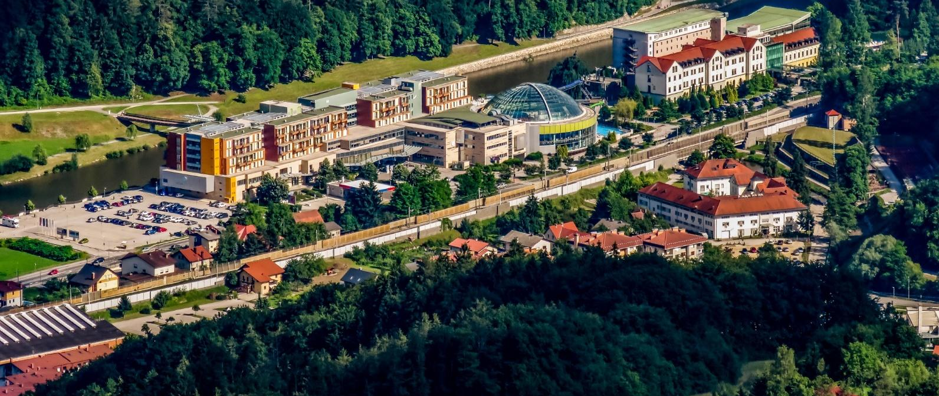
Hotel: Hotel Thermana Park Laško****superior
All reservationa go through: info@thermana.si with code BADMINTON25
The deadline is 15. 8. 2025
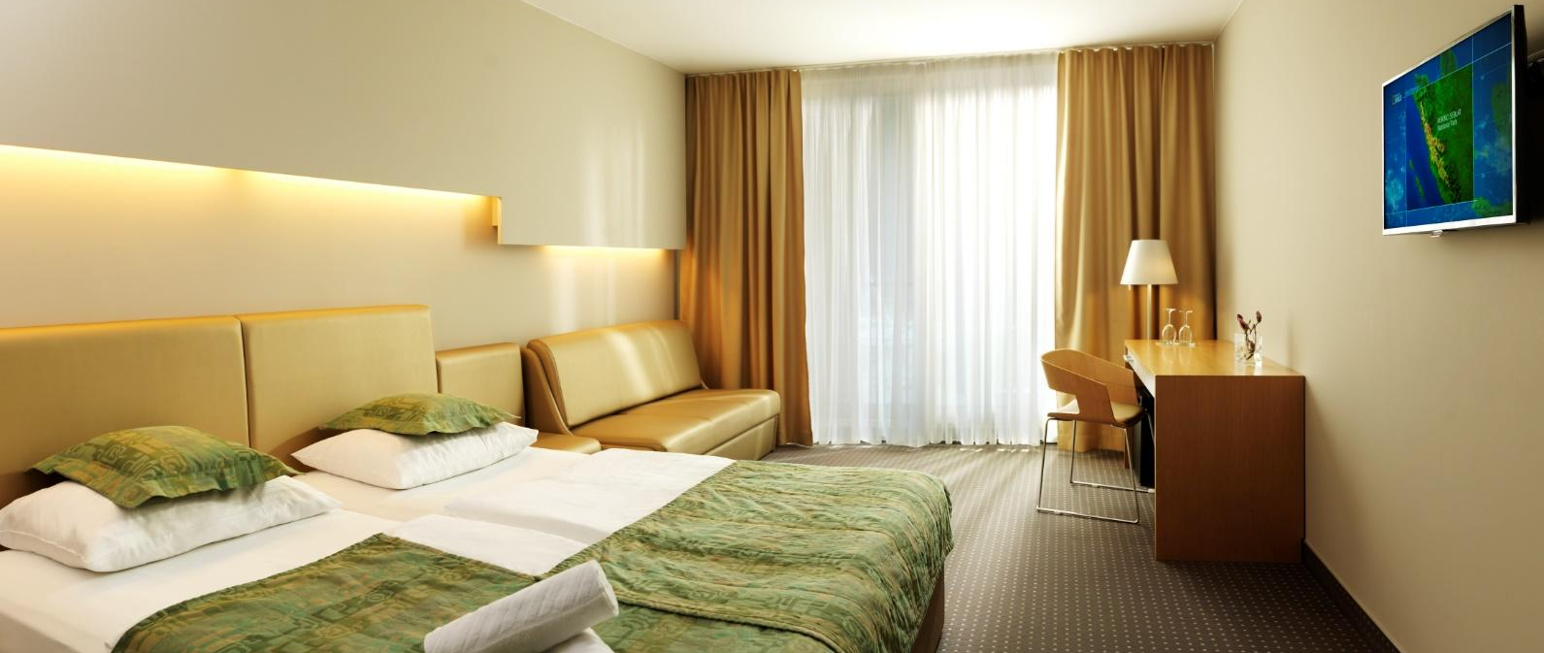
Bed and breakfast
Accommodation in a triple room: €70.00 per person per night
Accommodation in a double room: €75.00 per person per night
Accommodation in a single room: €100.00 per person per night

The prices are net per person per night and include VAT and all applicable discounts.
Minimum stay: 2 nights. No additional commissions or discounts apply to the listed prices.
PRICE INCLUDES:
• Bed and breakfast
• Free Wi-Fi access in the hotel
MANDATORY AND OPTIONAL SURCHARGES:
• Dinner: €15.00 per person per day
• Mandatory – Tourist tax: €2.50 per person per night; €1.25 for persons aged 7 to 17.99
• Mandatory – Registration fee: €2.00 per person per stay
• Late check-out / early check-in: €50.00 per room
• Empty mini bar: €2.00 per room
All other surcharges according to the official 2025 price list.
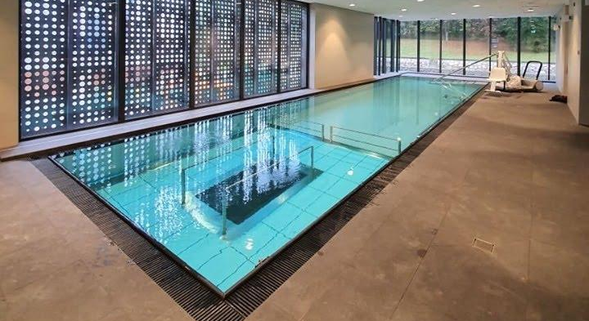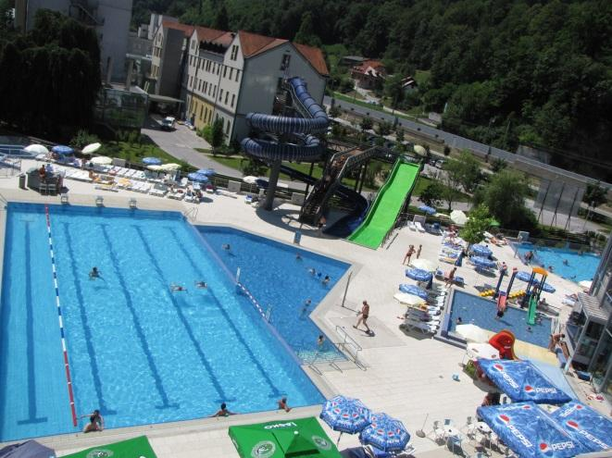

CANCELLATION POLICY:
• Free cancellation for the entire group/event up to 50 days before arrival
• Cancellation 49–30 days before arrival: 20% of the total stay will be charged
• Cancellation 29–10 days before arrival: 50% of the total stay will be charged
• Cancellation 10–0 days before arrival: 100% of the total stay will be charged
• Individual guest cancellations must be notified at least 7 days prior to arrival (up to 10 persons) – free of charge
• Individual cancellations 6–0 days before arrival (up to 10 persons): 100% of one night stay will be charged

MARTINOVA IZBA AND VILLA AINA
Bed and breakfast
Accommodation: €55.00 per person per night
The prices are net per person per night and include VAT and all applicable discounts.
PRICE INCLUDES:
• Bed and breakfast
• Free Wi-Fi access in the hotel
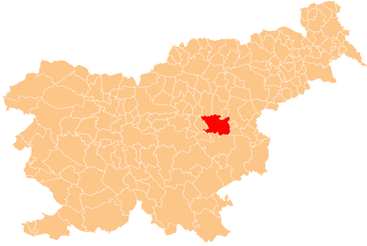

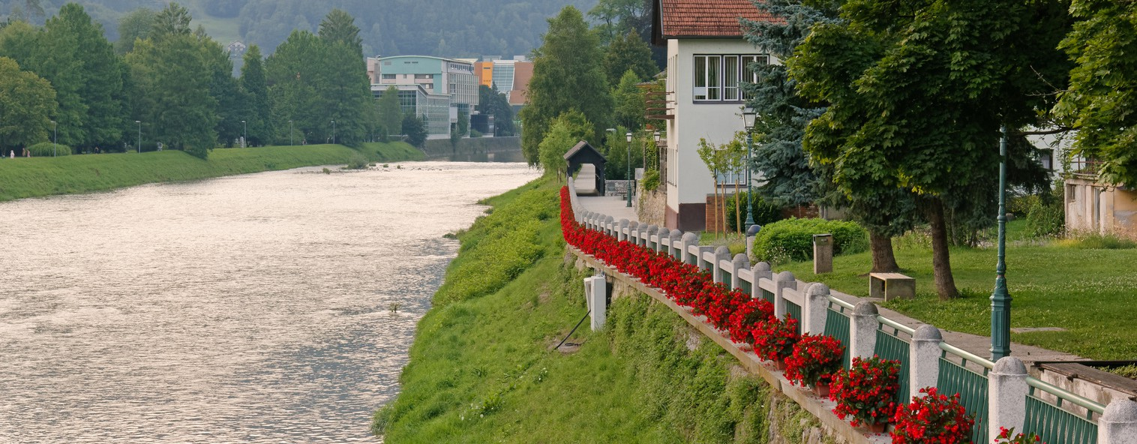


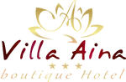


SLOVENIAN
VIBES RESORT

About Slovenian Vibe Resort

”Slovenian vibes” resort is part of Slovenia Green destination Laško.
The resort is founded for the tourists groups accomodation to invite them in the full immersion into Slovenian culture, cuisine and nature.

It is situated in the thermal and beer arla – Laško.

 Our great location:
300m from the thermal center Laško, in the Central Slovenia,
close to the historical places in Celje, Pekel cave, Beer factory, Šmartinsko lake.
Gives a lot of opinions for tourism.
The central location of resort provides easy access to Celje (10min), Zagreb, Ljubljana, Maribor (50/60min).
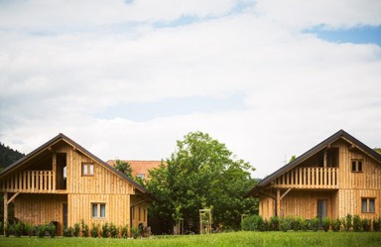
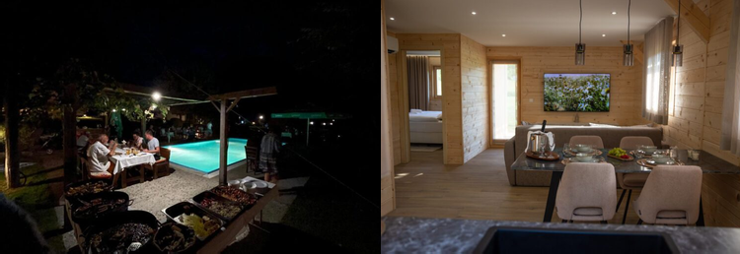
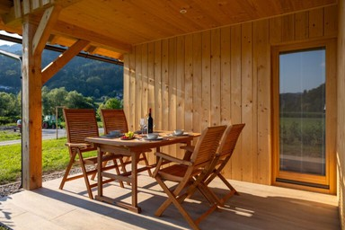

Swimming pool

What it includes?

Villa Aina boutique hotel


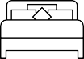 Deluxe suits and rooms with balcony or terrace Wellness with VIPspa and massage treatments
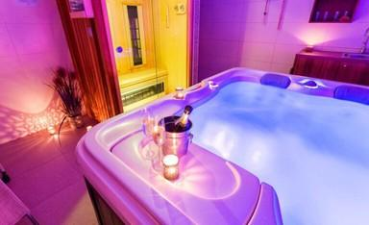
 Breakfast

Martinova Izba

Authentic Slovenian restaurant

Wooden bungalows and rooms

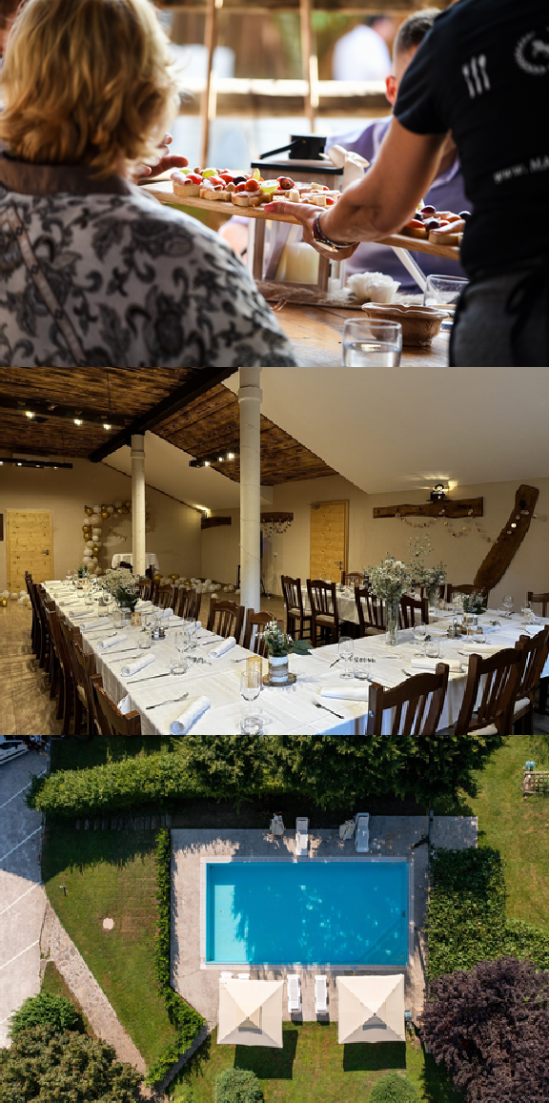
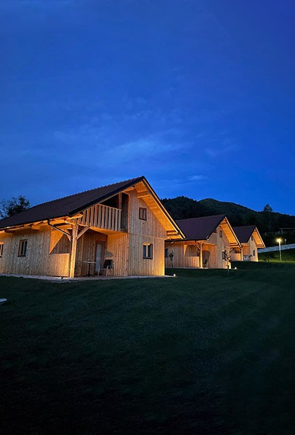

What we provide?

We provide for tourist groups:

Full immersion into Slovenian culture, cuisine, nature

Accommodation in comfortable hotel room and wooden bungalows

Rich breakfast

Slovenian style dining with authentic food, alcohol specialities and music

Special party organization (per request)

Wellness and VIP spa treatments

Open pool in the warm part of the year

Easy access to the thermal pools all around the year (free access pay extra)

Big parking for the touristic buses
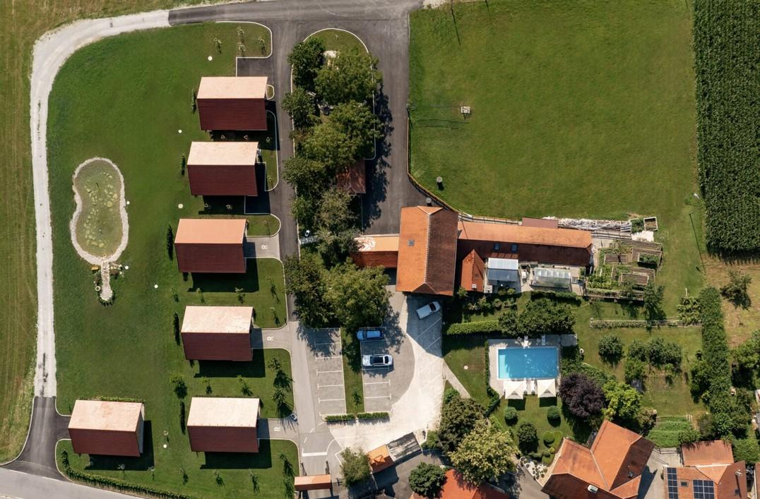

For group reservation please write on:


info@martinova-izba.com

+38670352711

